By leaving the peel on apples when making an apple sauce, the pectin is released and comes to the surface of the skin, making it readily available for the small intestine to help inoculate the gut microbiome and build the good bacteria.

Pectin feeds and increases an important brush border enzyme called *Intestinal Alkaline Phosphatase (IAP)* that helps to protect and support the gut. IAP helps to lower cholesterol if it is too high, lowers triglycerides if too high, helps to stabilise insulin sensitivity (stabilises blood sugar) and helps to reduce harmful endotoxins, known as *Lipopolysaccharides (LPS)* by 75% in your blood stream. It helps to stimulate the good bacteria, helping them to grab onto the walls of your intestines to stay there and form colonies. (Information from Dr Tom O’Bryan)

**Recipe**

* Take 5-10 organic apples
* Remove the seeds and dice but DO NOT PEEL
* Add water 1/3 of the height of the apples
* Add cinnamon if desired (use Ceylon cinnamon, which is the “true” cinnamon)
* Turn on high and when you see a shine on the apples, turn it off
* The shine means you have released the pectin from the apple and it is now on the surface

Eat a tablespoon or more each day.

I froze mine in a silicone muffin tray (Lakeland) and then put them in silicone bags in the freezer. I don’t like to use plastic (these ones were from Amazon - https://www.amazon.co.uk/gp/product/B0897JNL7W/ref=ppx_yo_dt_b_asin_title_o06_s00?ie=UTF8&psc=1)

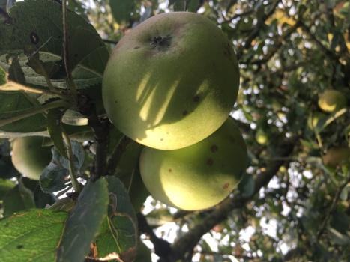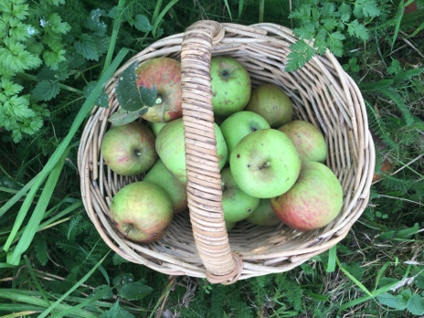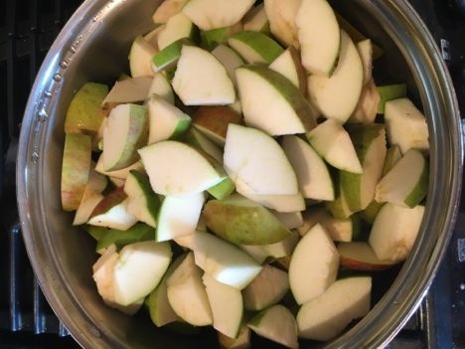

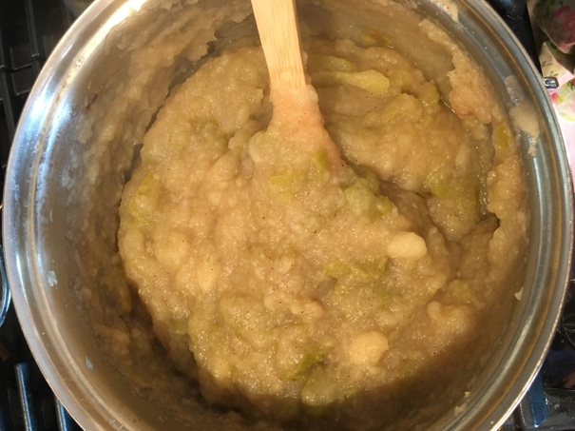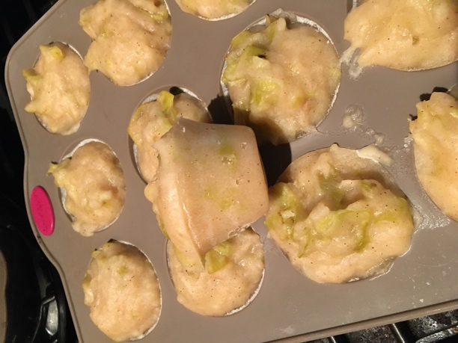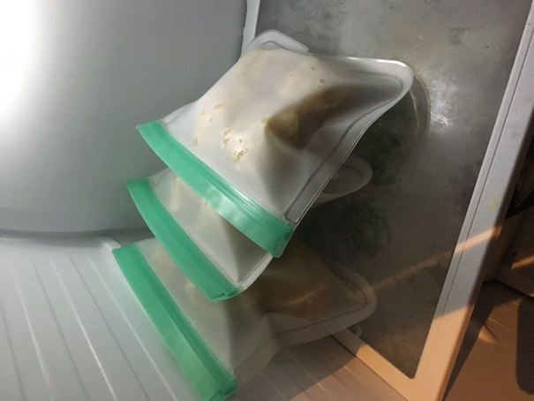

**Health Benefits of Apples on Gut Bacteria**

1. **Promotes beneficial bacteria growth**
   * Apple polyphenols and fibres (especially pectin) act as food for *Bifidobacteria* and *Lactobacillus*, supporting a healthy gut microbiome.
2. **Improves gut barrier function**
   * Apple compounds help reduce “leaky gut” by supporting intestinal wall integrity.
3. **Reduces harmful bacteria**
   * Certain compounds may lower populations of bacteria linked with inflammation and metabolic disease.
4. **Produces short-chain fatty acids (SCFAs)**
   * Fermentation of apple fibre in the colon produces SCFAs (like butyrate), which support colon health, immune balance, and reduce inflammation.

🌱**Key Plant Bioactive Compounds in Apple Skin**

* **Polyphenols (especially in skin):**
  + Quercetin (flavanol)
  + Catechin (flavanol)
  + Epicatechin
  + Procyanidins
  + Chlorogenic acid
  + Phloridzin (unique to apples)
* **Dietary Fibre:**
  + Pectin (major prebiotic fibre in apples)
  + Insoluble fibre (cellulose, hemicellulose, lignin)
* **Other antioxidants:**
  + Triterpenoids (especially in the waxy skin, with anti-inflammatory effects)

Info from Dr Carol Hughes, Microbiologist