There can be various reasons for sleep issues or insomnia which are mostly related to diet, breathing, lifestyle and stress. Blood sugar imbalance and excess caffeine are big factors in sleep issues, as well as nutritional deficiencies and other stressors.

The time that you wake up can be telling. Many clients with sleep issues wake between 1 and 3am which is when the liver is detoxifying – liver meridian time in Chinese Medicine. Waking between 11-1am is gallbladder time. The gallbladder is the decision maker, so you may need to make a decision – therapeutic journaling at this time could be helpful.
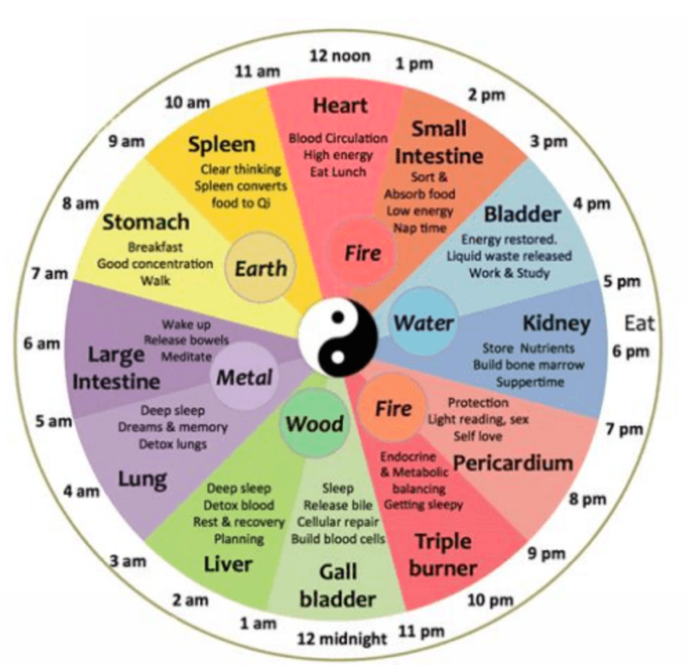

Nightmares and bad dreams can be caused by a liver that is jammed up with toxins, such as homocysteine (from sluggish methylation – see below), which can sneak past the outlet liver valves thus causing irritation to the heart and brain, which can set off a horror show of bad dreams. If you wake up sweating, it is likely blood sugar balance issue.
When circadian rhythms are disrupted through shift work, short-term effects can include insomnia, while long-term effects may include obesity, type 2 diabetes, and high blood pressure. Other causes of sleep issues can include mouth breathing or sleep apnoea.

Shift work can alter the body’s circadian rhythms - internal body clocks that respond to natural daylight and darkness. Consequently, blood sugar levels can be affected. Altering sleep times can lead to greater problems with hyperglycemia (too high blood sugar) and hypoglycaemia (low blood sugar). Research carried out on air hostesses discovered that long haul trans-continental flight attendants suffered from impaired memory, higher glucocorticoid levels and a smaller temporal lobe (which contains the hippocampus, an important brain area for memory).
Research has shown that just two nights of sleep restriction to 4 hours per night resulted in a 40% reduction in glucose tolerance and a 30% increase in a desire for calorie dense foods such as cake and potatoes.

Other research suggests that one night of deprived sleep equates to the equivalent of 6 months on a junk food diet. Often when we’re sleep deprived, we crave unhealthy food — even one night’s interrupted sleep can increase insulin resistance, which can lead to higher blood sugar levels, cravings, mood swings and that “cannot function without a pastry or caffeine” mentality.
We have many distractions now, especially the electric light which can allow us to work into the early hours. Combine this with the internet, play stations and television and we are on a slippery slope to sleep deprivation.
In 1910 the average American had 9 hours sleep a night. This has changed to 7.5 hours and decreasing. A study by the sleep tracker Lingo showed that on average Brits get six hours and 20 minutes a night, one hour and 40 minutes less than the recommended eight, totaling a deficit of 607 hours a year. Up to 63 per cent of respondents sin the study aid their energy levels were at an all-time low as a result, with stress, lack of exercise and poor diet posited as potential reasons for our collective sleep deprivation. Research suggests that we need 8 hours good quality sleep a night.
Sunlight triggers a healthy release of the stress hormone cortisol, which “acts as a wake-up signal” and “starts a timer for the onset of melatonin” — the hormone that helps to control our sleep cycle. Spending between 2-10 minutes outdoors on sunny mornings and 15-20 minutes on cloudy days can therefore be very beneficial.
The use of computers, mobile phones and watching television late at night affects the production of melatonin, and thus our overall ability to sleep soundly. A lack of melatonin (the “sleep hormone”) can affect sleep. The pineal gland is an endocrine organ which produces hormones, most notably, melatonin which controls sleep and wake cycles, circadian rhythm and controls premature puberty. The production of melatonin is influenced by how much light or darkness there is in the external environment. Any presence of light, especially artificial, will hinder production of it. The use of computers, mobile phones and watching television late at night affects the production of melatonin and thus our overall ability to sleep soundly.

The hormone serotonin is our “on” switch stimulated by the light of dawn, but melatonin is our “off” switch, activated by dusk. The rise in melatonin is the body’s cue that it is time to repair and regenerate. As light decreases in the early evening, the retina of your eye begins to turn serotonin into melatonin, the “sleep hormone”. Omega 3 deficiency can contribute to low melatonin. Inflammation suppresses melatonin, so inflammatory foods such as – gluten, dairy and sugar could be a factor, especially if one has difficulty falling asleep.
Another relevant factor in the production of melatonin is whether a person is methylating efficiently. Serotonin is acetylated in the pineal gland and then methylated to produce melatonin. If someone is a poor methylator (for example, they don’t have the MTHFR enzyme to break folic acid down to methyltetrahydrofolate), then they may not be producing melatonin efficiently and this could be causing or contributing to many symptoms, including poor quality sleep. Stress will slow methylation.
Another relevant factor in the production of melatonin is whether a person is methylating efficiently. Methylation is a chemical reaction that occurs in every cell and tissue in the body and requires Vitamin B6, B12, folate, and cysteine to be converted effectively. An important part of methylation is detoxification – converting the toxic amino acid (homocysteine) into a beneficial amino acid (methionine). Stress slows methylation but some have genetics that can slow the process – MTHFR genes.

The"P5P” body-ready form of Vitamin B6 is needed for the production of melatonin from the pineal gland, Research hasn’t found a direct link between P-5-P levels and insomnia, however taking vitamin B6 before bed increased melatonin release from the pineal gland in a study of 120 children. Vitamin B12 is a necessary co factor in the manufacture of melatonin. Carotenoids also produce melatonin which is involved with the circadian rhythm.

Melatonin levels are at their lowest in the spring, together with vitamin D, which correlates with the seasonal symptoms and flares related to certain autoimmune conditions (PMID: 28624334). Keep an eye on your circadian nutrients at this time of year as we head into springtime in the northern hemisphere. Vitamin D is also important for sleep. It is easy to check your Vitamin D levels with a home finger prick test. I usually give clients a link to an inexpensive test in their plans.

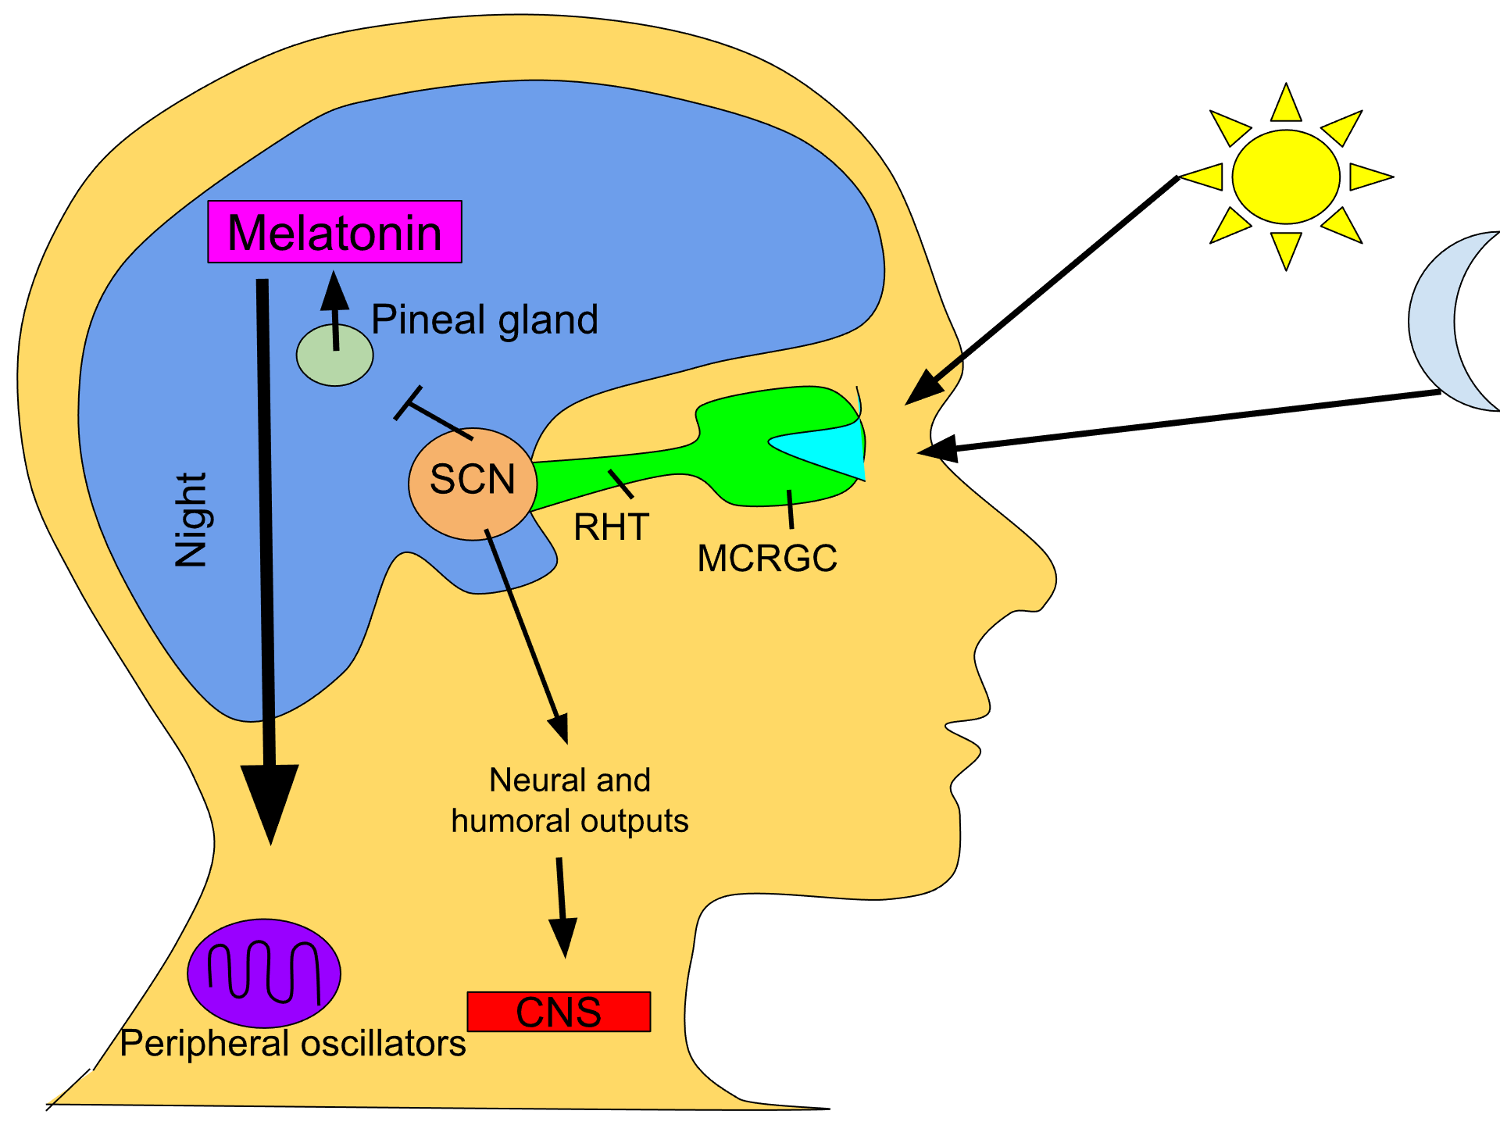

When the eyes are exposed to sunlight, the pineal gland’s melatonin production is suppressed, resulting in the secretion of hormones that promote wakefulness. Conversely, in the absence of light, the pineal gland synthesizes melatonin unabated, leading to feelings of drowsiness and facilitating the onset of sleep. - Wikipedia

By Srruhh - Own work, CC BY-SA 4.0, https://commons.wikimedia.org/w/index.php?curid=79485980

Cortisol (the stress hormone) and serotonin antagonise each other because when cortisol is high, serotonin is lowered. If we are eating as melatonin is coming up – in the evening – we suppress melatonin and secrete cortisol. However, if sleep issues are a related to blood sugar, a small protein-rich snack before bed can actually be helpful for some. Caffeine, as a stimulant, will also increase cortisol levels.

Many will reach for caffeine when they have been awake in the night which, as a stimulant, raises adrenaline and blood sugar temporarily and gives the adrenals a kick. Eventually, after the adrenals have been repeatedly kick started, this will take its toll on the body, blood sugar, hydration and the adrenals. Caffeine also binds to adenosine receptors in the brain to block the release of adenosine, a sleep-promoting chemical, that builds up over the day.

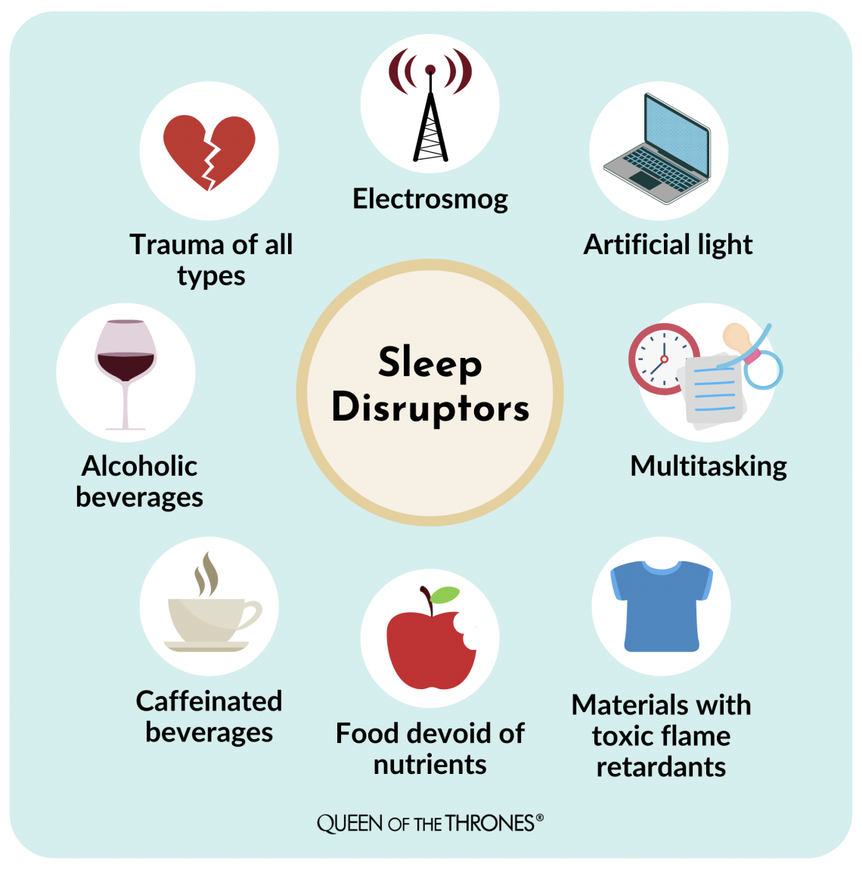

Personal Habits

Setting yourself up for sleep

- Fix a bedtime and an awakening time, do not let these times to drift as the body “gets used” to falling asleep at a certain time but only if it is relatively fixed.
- Ideally, avoid napping during the day. Late afternoon is often a “sleepy time” for many people, and it is not generally a problem taking a little nap of less than a maximum of 40 minutes.
- Avoid caffeine and chocolate 4-6 hours before bedtime – it may be that you may need to avoid these for even longer before bed.
- Avoid heavy, spicy, or sugary foods 4-6 hours before bedtime as these can affect your ability to stay asleep.
- Try a light non-sugary snack, before bed – we can often awake at night when blood sugar fluctuates too low. Warm milk (of choice) may be helpful.
- Taking two kiwi fruit before bed is said to induce a peaceful night’s sleep. This may be due to their high vitamin C content that helps support the adrenal glands.
- Try drinking a glass of water before bed and put a pinch of Himalayan or Celtic Sea salt on the tongue. Allow the salt to dissolve on the tongue, not swallowed, and should not be brought into contact with the palate. This has been found to induce an immediate feeling of relaxation and sleep within a few minutes, followed by a found night’s sleep. It is thought that the sale and water alter the rate of electrical discharge in the brain and therefore induce sleep.
- Exercise regularly, but not right before bed. Regular exercise, particularly in the afternoon, can help deepen sleep. Strenuous exercise within 2 hours before bedtime however can decrease your ability to fall asleep. Try a snack before bed to see if this helps you sleep longer. Play around with different types of snacks with varying amounts of protein and carbohydrate to see which works best for you. This is a temporary measure and won't be needed once your body is more balanced.
- Establish a pre-sleep ritual such as a warm bath or a few minutes reading a relaxing, non-work, non-study related book.
- Practice relaxation techniques before bed to help relieve anxiety and reduce muscle tension such as yoga, Buteyko breathing – slow nose breathing, or listen to the MP3 Guided Breathing track if I have given this to you or ask me for it.
- Don’t take your worries to bed. Leave your worries about job, school, daily life etc behind when you go to bed. Develop meditation or mindfulness techniques to help with this – this becomes easier with practice. Therapeutic journaling before bed can also be helpful if insomnia is caused by racing thoughts.
- Avoid looking at your mobile phone, computer (and TV if possible) for at least one hour before bed. If the brain sees blue light, it thinks it is daytime and does not trigger the production of melatonin, the “sleep hormone”.
- Increase foods with omega 3 as above, which is needed to produce melatonin, the “sleep hormone”
- Avoid waking when it is dark in the morning
- Upon waking, go outside and let your eyes have direct contact with blue light (daylight) to regulate the circadian rhythm and for melatonin to be released later in the day.
- Get into your favourite sleeping position. If you don’t fall asleep within 15-30 minutes, try getting up, go into another room and read until sleepy.
- Keep a glass on your bedside and drink it as soon as you wake. A study showed those who slept only six hours a night had a risk of dehydration up to a 59 per cent higher than those who slept seven to eight hours. Researchers speculated this could be caused by the hormone vasopressin, which signals the kidneys to retain fluid during sleep. The brain’s pituitary gland releases more vasopressin later in the sleep cycle — wake up stressed at 5am and your body will conserve less water. Mouth breathing at night will also trigger vasopressin.

Cont…..

Sleeping Environment
- Turn off phone and all electrical equipment in the room (see EMF section later for info)
- Reserve your bed for sleep only. Do not use the bed as an office, workroom, or recreation room. Let your body “know” that the bed is associated with sleeping.
- Make sure the room is totally dark. Block out all distracting noise and eliminate as much light as possible.
- Use comfortable bedding. Uncomfortable bedding can prevent good sleep. Evaluate whether or not whether this may be part of the source of your problem and make appropriate changes.
- Avoid sugary snacks or alcohol close to bedtime as after a high rise in blood sugar, it may then fall low in the night and wake you up – you can have a healthy snack at night if this happens.
- Make sure your room is cool, not cold, as we only sleep when our temperature goes down.
- Breathing exercises before sleep or if you awake. We cannot sleep if adrenaline is high, and relaxed breathing brings this back down.
- There is a positive association between Vitamin D and sleep quality. It is usually a good idea to check your vitamin D levels in September to make sure your levels are enough for Winter as levels can halve between September and April.

Getting up in the middle of the night
Many people wake up one or two times a night for various reasons. If you find that you get up in the middle of the night and do not get back to sleep within 15-20 minutes, then do not remain in the bed “trying hard” to sleep. Get out of bed. Leave the bedroom. Read, have a light snack, do some quiet activity, or take a bath. You will generally find that you can get back to sleep 20 minutes or so later. Do not perform challenging or engaging activity such as office work, housework etc. Do not watch television or go on to a computer.
Television
Many people fall asleep with the television on in their room. Watching television before bedtime is often very unhelpful. Television is a very engaging medium that tends to keep people stimulated. The general recommendation is that the television is not in the bedroom. At the appropriate bedtime, the TV should be turned off and we should go to bed. Too much light at the end of the day can keep you awake – this includes computers and phones. Some people find that the radio helps them go to sleep. Since radio is a less engaging medium than TV, with no light, this might be a better option.

Electrical Equipment and Electromagnetic Frequency (EMF) & Toxins
For some people, electrical equipment and EMF can contribute to sleep problem, as can toxins in the room. Have a think about how you can detox your room: -
- Turn off all electrical equipment especially mobile phone, electric alarm clocks, electric blankets, anything on standby mode.
- If sheets are not 100% organic cotton, the room has recently bene painted, new furniture, carpets, curtains, wallpaper, consider a couple of house plants in the bedroom to help remove the toxins – see House Plant Fact sheet on the website. Different plants can remove different toxins.
- If you do have to re-paint, or re-decorate your room, consider the toxins that are given off. There are no toxin free paints, but some are less toxic. However, consider how these might affect your sleep, and health.
- Remove all artificial fragrance, perfumes, candles, reed diffusers etc.
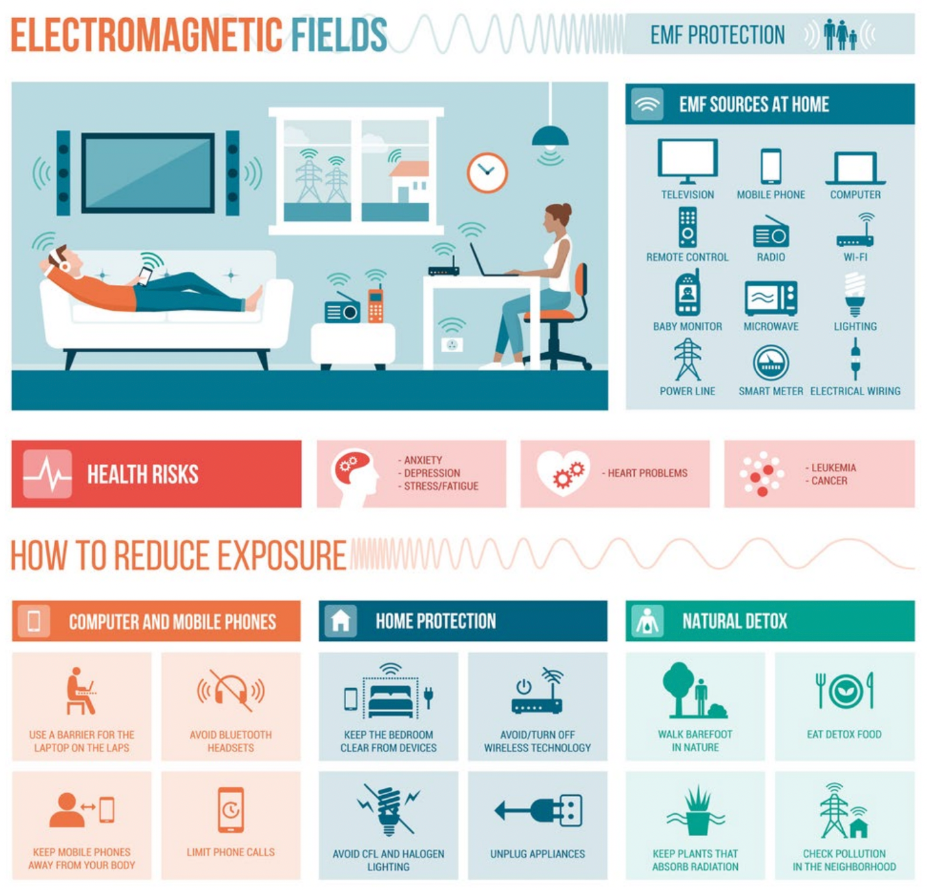

Metaphysical Reasons for Insomnia

“Psychological studies have proven that insomniacs are generally emotional, and anxiety ridden. If you suffer from frequent insomnia, your sleeplessness probably reflects restlessness in your waking life. You are trying to stay awake so that you will resolve the issues that are preoccupying you. Once you understand that sleep brings comfort and solutions, you will find you are determined to settle the unrest in your life.” From “Your Body’s Telling You: Love Yourself!” by Lise Bourbeau

Other Factors

The reason that someone has sleep problems will be individual to them, and so it is finding out the root cause of the individual’s problem that is important. Whether a person has difficulty falling asleep, wakes up in the night, too early in the morning, wakes up sweating, the time a person wakes up, can all have differing root causes and we will have looked at those potential root causes when taking your Case History.

Physical factors are also known to upset sleep including stress, arthritis, shingles, acid reflux, heartburn, menstruation, headaches, hot flashes, pain etc.

Psychological and mental health problems such as depression anxiety and stress are often associated with sleeping difficulty. In many cases, difficulty staying asleep may be the only presenting sign of depression. Therapeutic journaling before sleep, or if you wake up, can be a brilliant way to get any racing thoughts out of the head and on to paper. It is important to tear up what you have written down.

Many medications can cause sleeplessness as a side effect.

Mouth-breathing, snoring and sleep apnoea will affect quality of sleep – they turn on the sympathetic nervous system (fight or flight). Sleep apnoea needs to be addressed by a sleep clinic and if not dealt with can result in diabetes, high blood pressure etc. Buteyko Breathing along with dietary and lifestyle changes can be helpful in supporting these.

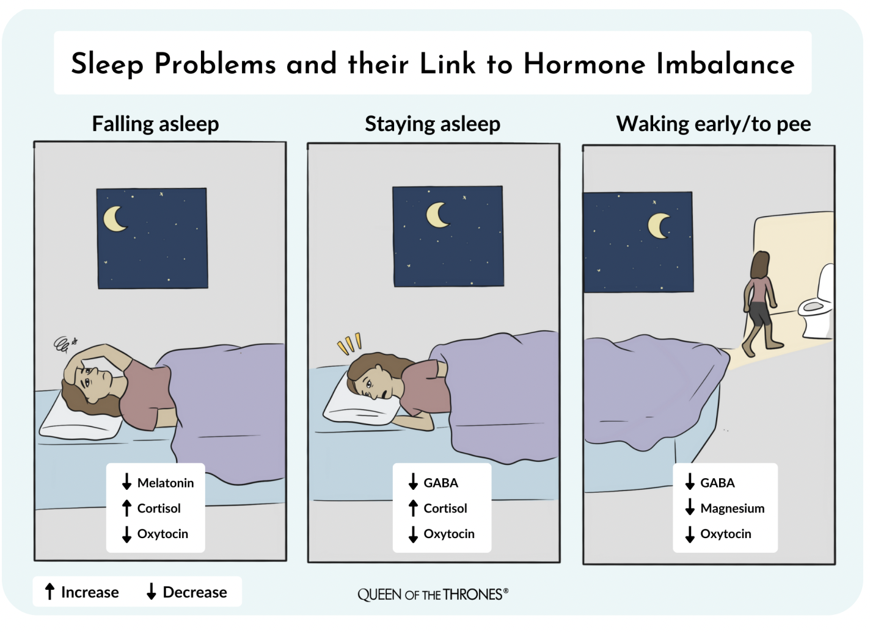

Other Support
Dietary and lifestyle changes can have a huge impact on sleep quality. If sleep problems are chronic, then one may need to really have a think about addressing lifestyle and potentially your job or career. For instance, any job that involves shirt work or night work such as air stewards for example may eventually over time struggle more than others with their health depending on what else is going on. Research found that Two nights of sleep restriction to 4 hours per night can result in a 40% reduction in glucose tolerance and a 30% increase in a desire for calorie dense foods such as cake and potatoes. One night of deprived sleep can equate to the equivalent of 6 months on a junk food diet.
d diet
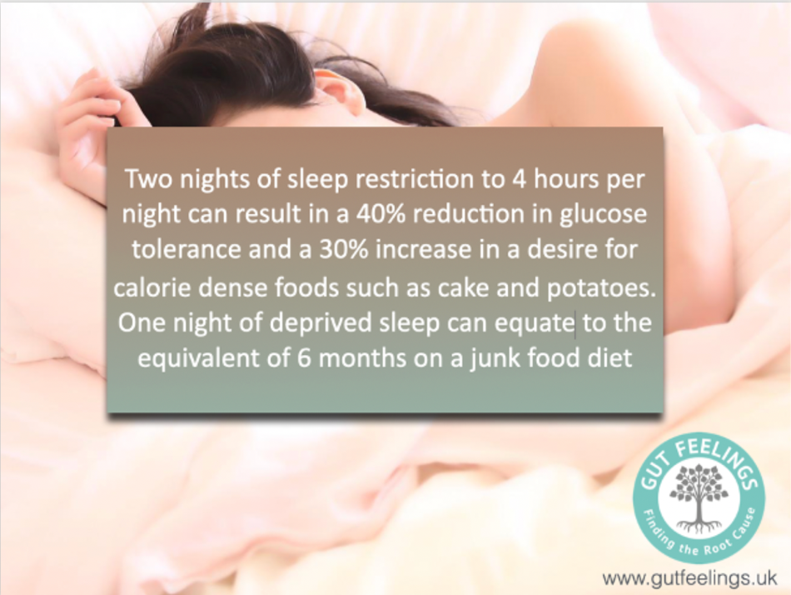
In turn, the better you are able to sleep, the more balanced your blood sugar and your minerals will be. Balancing blood sugar and reducing anxiety can have a big impact on positive sleep quality. Sometimes I may suggest supplements to help with sleep until you get back on track.
If the above doesn’t improve sleep, one may need to think outside the box, for instance a post-tonsillectomy scar can cause an interference field, as well as internal scarring in non surgerised patients who have had many bouts of tonsillitis and can restrict blood flow to the brain and contribute to many neurological symptoms including insomnia, anxiety, depression and memory loss.

Sometimes parasites can cause physical discomfort or because they are often nocturnal beasts that are active during the night.

I can use Kinesiology muscle testing with my sleep kit of vials, and other methods, to help determine root causes.

Naturopathic Hydrotherapy Therapeutics for sleep

Cold Water Foot Wash
This is exactly as it sounds; wash your feet with cold water before bed – about 10-30 seconds on each foot. Don’t dry them but go straight to bed. This helps to draw the energy down to the feet and take it away from the head, so is particularly useful for an active mind when you go to bed.
Cold Wet Cotton Socks
Wet some cotton socks in cold water and put them on and then cover them with some dry wool socks. This also helps to draw the energy down towards the feet and helps to aid sleep by reducing over-active thought processes.

Ayurvedic Techniques
It is important to calm the mind before bed. An active mind with many thoughts is a sign of disturbed Vata in Ayurveda medicine. To pacify Vata, massage and breathing are suggested. S self-massage (especially the feet) before bed with warm sesame seed oil, almond oil or coconut oil, together with breathing exercises helps to balance this energy in the body. The oil can be applied before a bath and then washed off or left on all night.
Alternate Nostril Breath

- Breathe in through the left nostril, closing the right with the thumb, to the count of four.
- Hold the breath, closing both nostrils, to the count of eight or less if uncomfortable.
- Breathe through the right nostril, closing the left with the ring and little fingers, to the count of six.
- Breathe in through the right nostril, keeping the left nostril closed with the erring and little fingers to the count of 4.
- Hold the breath, closing both nostrils, to the count of eight (or less if uncomfortable)
- This constitutes one round.
- Do 5 rounds in all

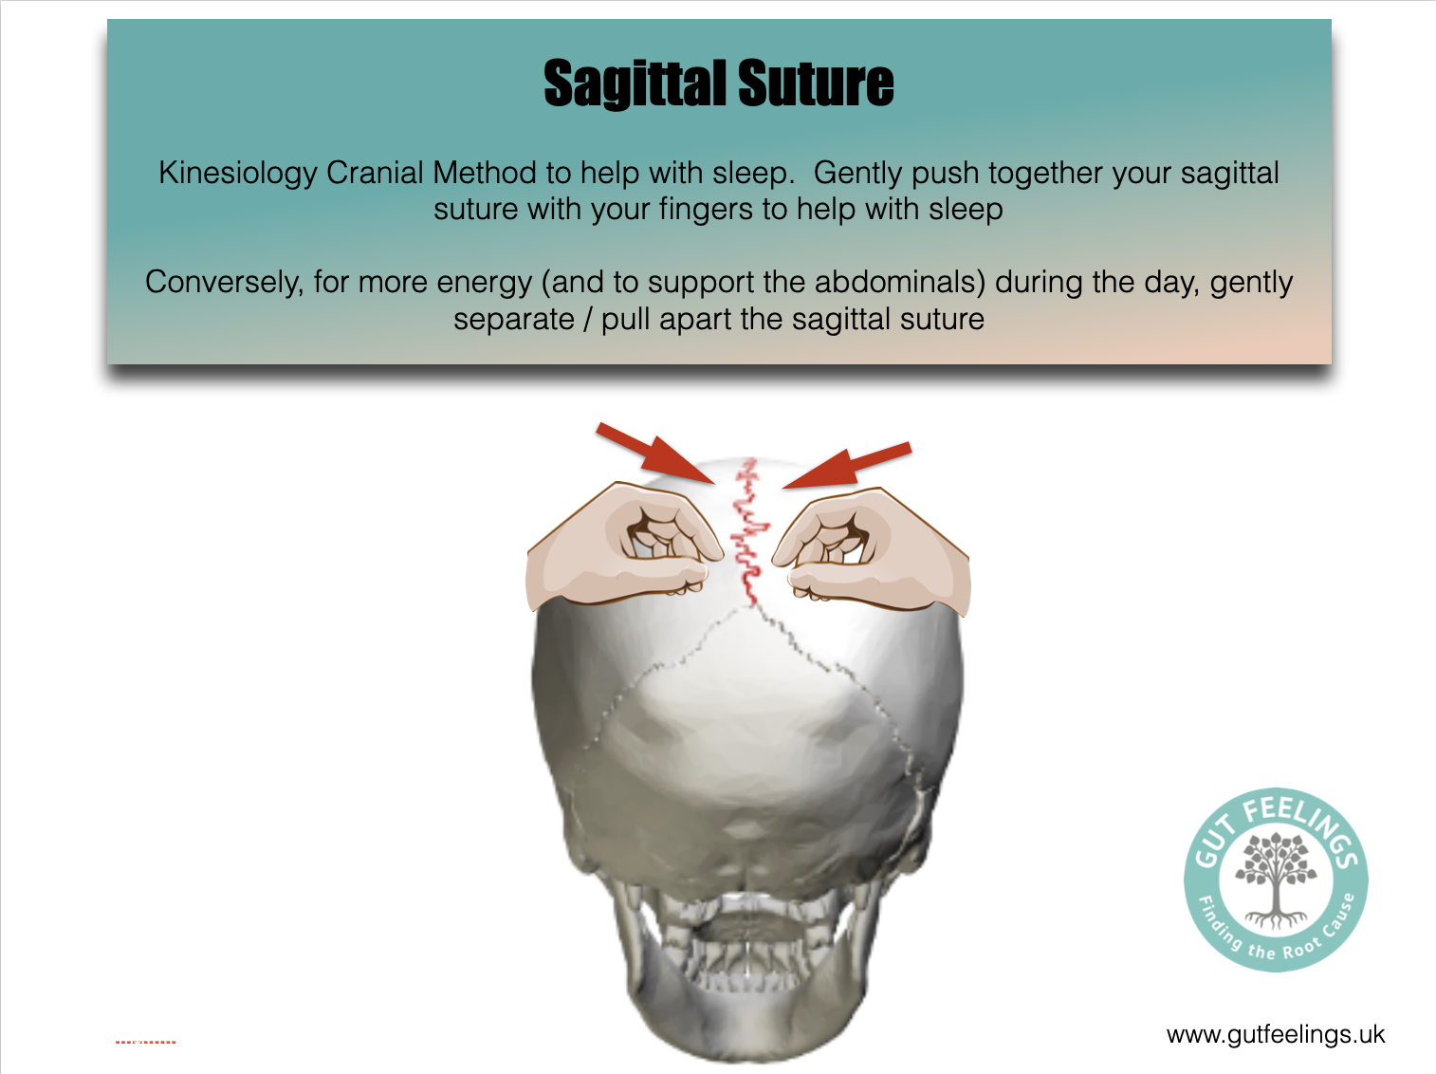
Another kinesiology method to help with sleep is to gently press together the sagittal suture in your head.

Books
- “I can make You Sleep” by Paul McKenna – comes with a hypnosis download code that re-sets your body's natural sleep mechanism so that you will automatically find it easier to get deep restful sleep and have energy to achieve what you want and improve your overall of quality of your life.
- “The Effortless Sleep Method” by Sasha Stephens – also her website http://www.sashastephens.com/
- “Why We Sleep” by Matthew Walker

